# TEAM ID: PNT2022TMID08472

# TEAM LEADER: MARIA MANOJ KUTTOMPARAMBIL

# TEAM MEMBER 1:K.KAVYA

# TEAM MEMBER 2:A.BHUVANESHWARI

# TEAM MEMBER 3:A.AGASHIYA

# PROCEDURE TO CREATE CLOUDANT -DB

* To create a Data baSE USING IBM cloudant

service

**Step 1:** Open the IBM cloud website. In the Resource list page, under Services click Cloudant-g4.You’ll be redirected to a new page, click Launch Dashboard.

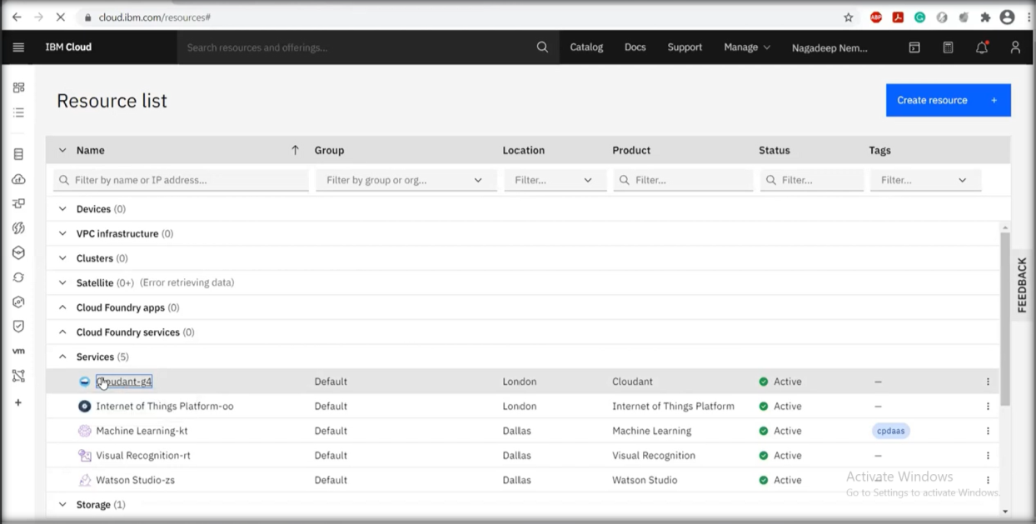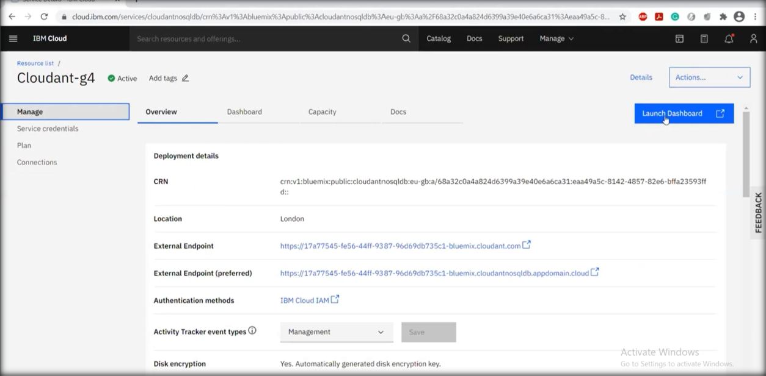

**Step 2:** You’ll be redirected to databases page. Provide a database name and select partitioned and then select create. Then click

create document.

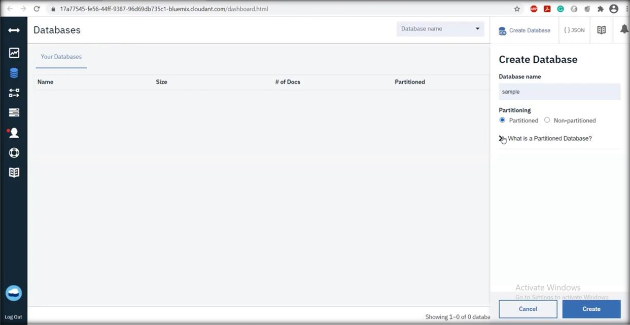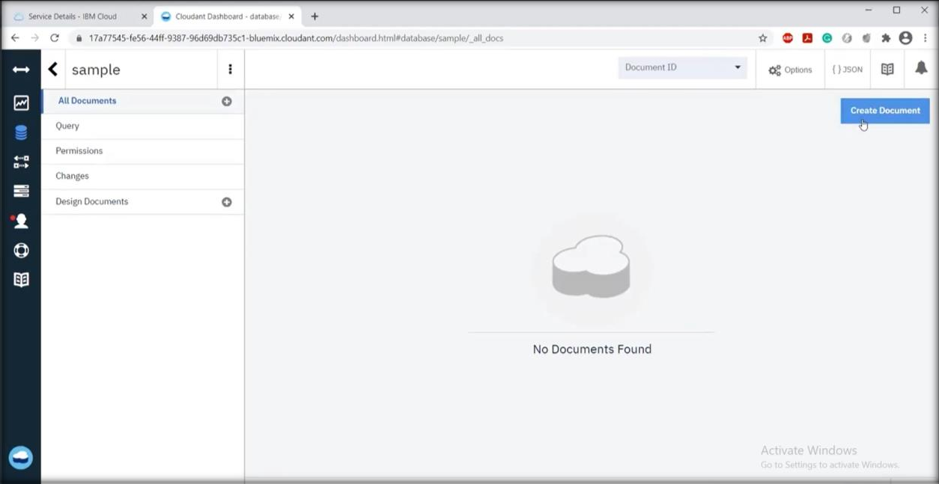

**Step 3:** A new page will appear with id. Enter your database and

create.

